1. ***Write a program to illustrate various types of text***

<!doctype html>

<html>

<head>

<title>Text formatting </title>

</head>

<body>

<h1>This web page contain all text formatting tags.</h1>

<b>Bold text</b>

<br><br>

<i>Italic text</b>

<br><br>

<u>Underline text</u>

<br><br>

<big>Big tag meeans size greater the normal size.</big>

<br><br>

<strike>dislplay stike throught</strike>

<br><br>

<small>small tag means size smaller than normal</small>

<br><br>

<p>superscript tag .just printing like this : &nbsp;&nbsp;X<sup>4 </sup></p>

<p>subsscipt tag, just printing like this : &nbsp;&nbsp;H<sub>2</sub>o</p>

<marquee> moving text on the sreening</marquee>

</body>

</html>

***OUTPUT:***

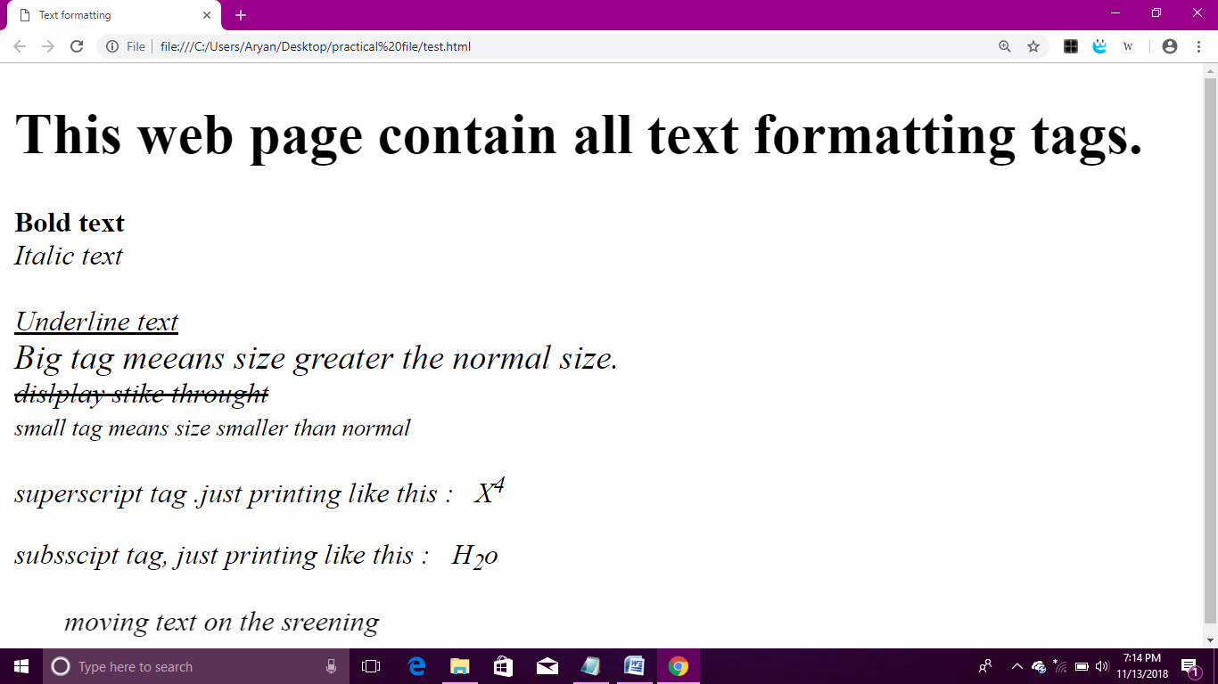

1. ***Write a program to illustrate preformatted tag***

***and abbreviation tag.***

<!doctype html>

<html>

<head>

<title>Preformatted and Abbteviation tags.</title>

</head>

<body>

<p><b>This is preformatted tag. and used to display text as you write on your text editor.</b></p>

<pre>

Hello this is the simple web page.

that show how to use pre formatting tag. It display content as you write your source code.

</pre>

<br>

<p><b>This is abbreviation tag.</b></p>

The <abbr title="FtP is file tranfer protocol.it is comman method to share your documents using this protocol.">FTP</abbr> are always used in document sharing.

</body>

</html>

***OUTPUT:***

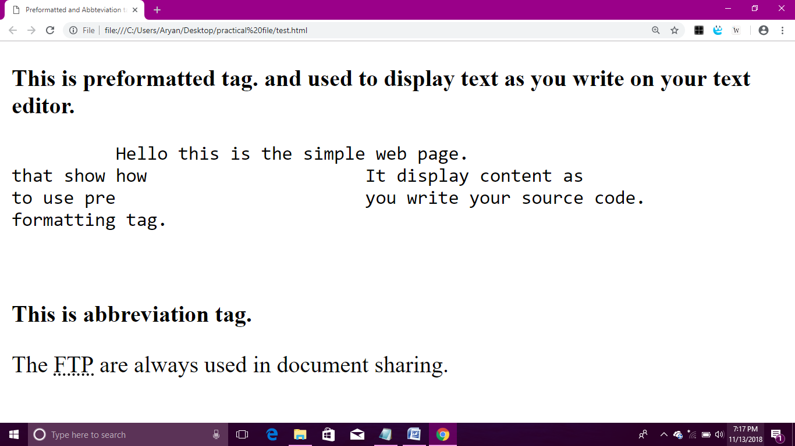

1. ***Write a program to link a web page to another web page.***

***Condition: The linked page should be opened in a new window.***

<!doctype html>

<html>

<head>

<title>Linking a web page and opening in new tab or window</title>

</head>

<body>

<h1>India</h1>

<pre>

India is a vast country with second highest population in the world.

It is a country with diverse cultures,

traditions and beliefs. People in India celebrate unity in diversity.

Festivals like Diwali, Holi, Navratri,

Ramzan, Christmas etc. are celebrated by people across

India and create a sense of brotherhood and cultural unity.

Each festival has its religious and cultural importance.

</pre><p><a href ="https://www.indiacelebrating.com/"target="_blank">

Click here know more about Inida</a>

</body>

</html>

***OUTPUT:***

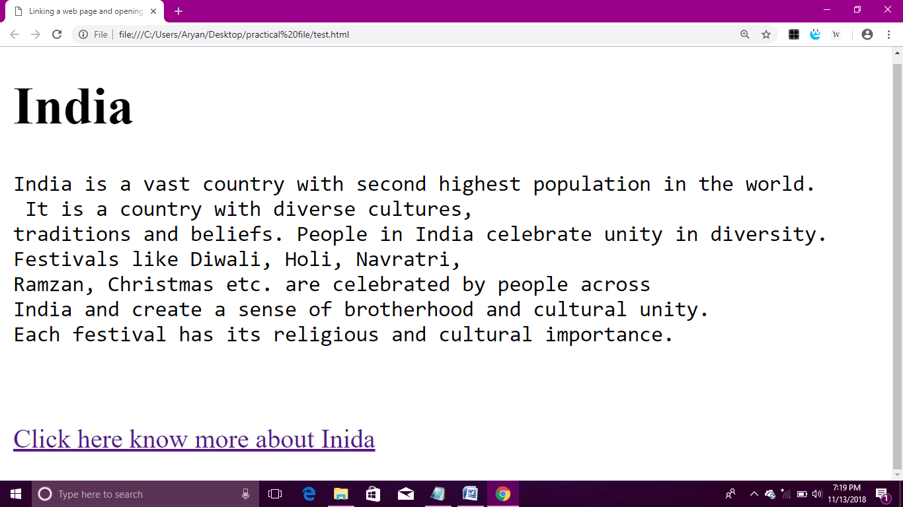

1. ***Write a program to insert an image in your web page***

***Also use this image to create a link to another web page.***

<!doctype html>

<htmml>

<head>

<title>Inserting an image and make it link of anther web page.</title>

<body>

<center>

<p><h3>This is the Govt.p.g.college sec-9 , image.<br><br>

Click over the image to open Govt.P.G.collge, sec-9 ,website </p>

<br><a href=" http://117.239.178.94/dhe/GovtCollege.aspx?data=49 " >

<img src ="C:\Users\Aryan\Downloads\college.jpg" height="500" width="1290">

</a>

</center.<br>

<br>

</h3></p>

</body>

</html

***OUTPUT:*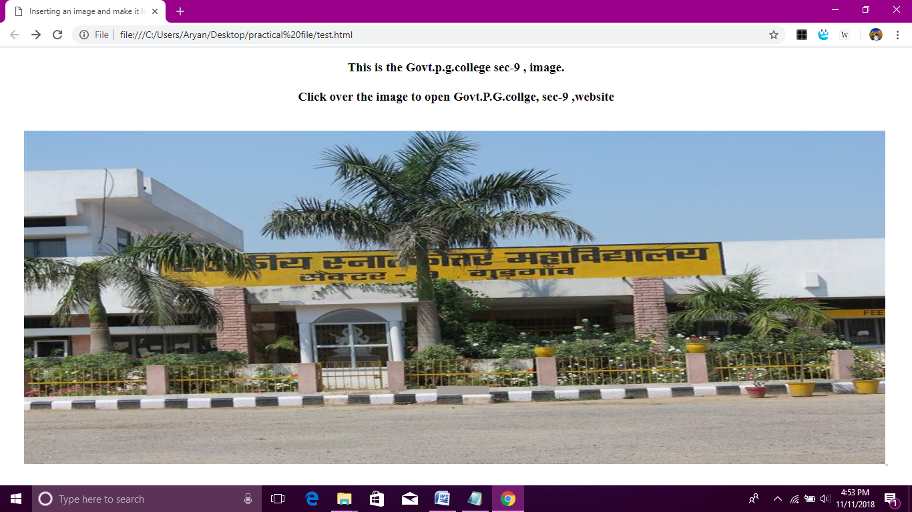**

1. ***Write a program to explain discription list.***

<!doctype html>

<htmml>

<head>

<title>.Decrcription list </title>

<body>

<dl>

<dt>C- language </dt>

<dd>It is the computer programming language and Dennis Ritchie was the deveoper of this language.It was developed in 1972 AT &T bell laboratory.(USA)</dd>

<dt>C++</dt>

<dd>It is the superset of c language and developed by Bjarne strotroupus in 1982.

It is object oriented programming language.</dd>

<dt>Java</dt>

<dd>It is the most popular computer programming language.It was developed in Sun Mircosystem. Nowdays the java is maintain by Oracle firm.</dd>

<dt>C shar(c#)</dt>

<dd>it is exactly copy of java and developed by Microsoft company.

It is also object oriented programming language.</dd>

</dl>

</body>

</html>

***OUTPUT:***

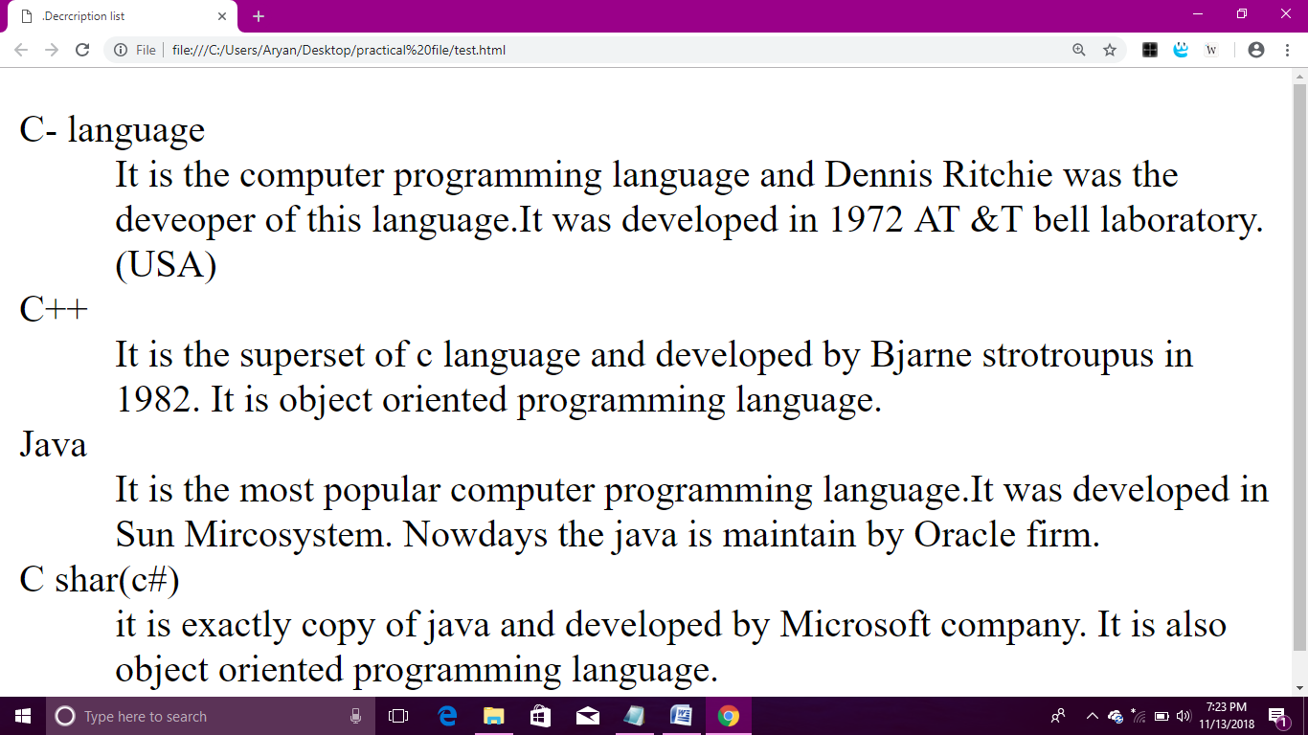

1. ***Write a program for the nested unorder list.***

<!doctype html>

<html>

<head>

<title>Unorder list</title>

<body>

<li>To make a webapplication:</li>

<ul type="disc">

<li>java</li>

<li>javascript</li>

<li>JSON</li>

<li>Jquery</li>

<li>AJAX</li>

<li>CSS</li>

<li>HTML</li>

</li>VBScript</li>

<li>Angular JSP</li>

<li>Drupal</li>

<li>Php</li>

</ul>

<li>Desktop Applicaion</li>

<ul type="circle">

<li>C language</li>

<li>c++</li>

<li>Java</li>

<li>Visual basic</li>

<li>C#</li>

<li>Python</li>

<li>Swift</li>

<li>Objective c</li>

<li>Androide</li>

<li>Rubby</li>

<li>Perl</li>

<li>Kotlin</li>

<li>Scala</li>

</ul>

</body>

</html>

***OUTPUT:***

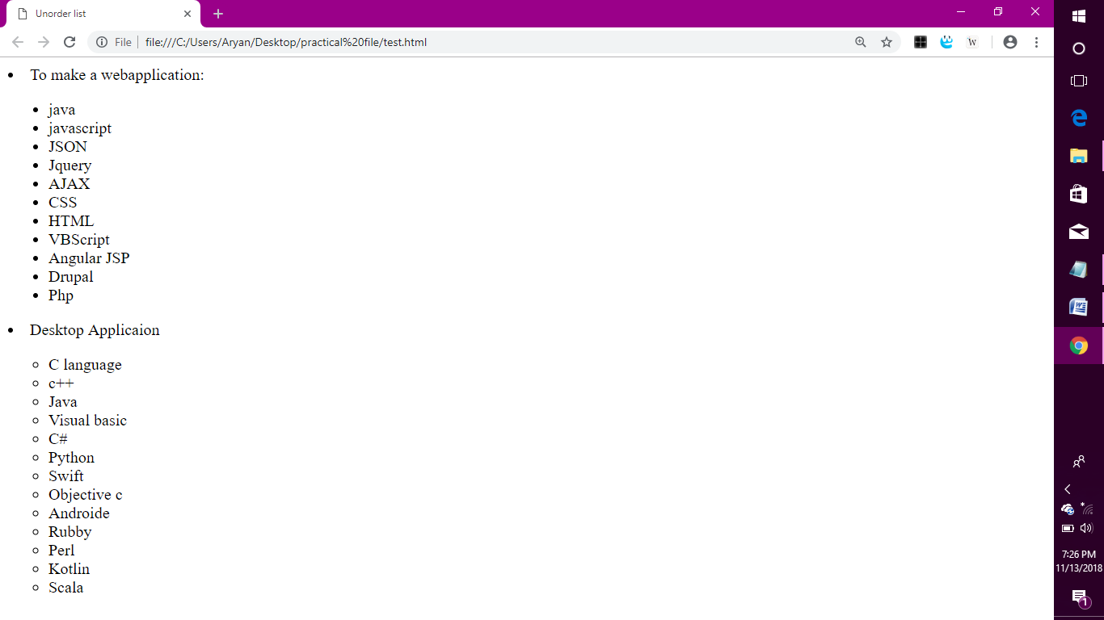

1. ***Writw a program to illustrate use of various form elements using the fieldset tag.***

*<!DOCTYPE html>*

*<html>*

*<head>*

*<title>Form tags and fieldset tag</title>*

*<body>*

*<pre>*

*<form>*

*<fieldset>*

*<font color=blue size=4><center><legend>step 1: personal information</legend></center>*

*first name <input type=text size=30>*

*Middle name <input type=text size=30>*

*last name <input type=text size=30>*

*</fieldset>*

*<br>*

*D.O.B <input type=text size=30>*

*Place <input type=text size=30>*

*state <input type=text size=30>*

*address <input type=text size=30>*

*country <input type=text size=30>*

*pin code <input type=text size=30>*

*jender <input type=text size=30>*

*occupation <input type=text size=30>*

*current status <input type=text size=30>*

*<center><br><pre><button> Subbmit</button> <input type=reset>*

*</pre></font>*

*</form>*

*</body>*

*</html>*

***OUTPUT:***

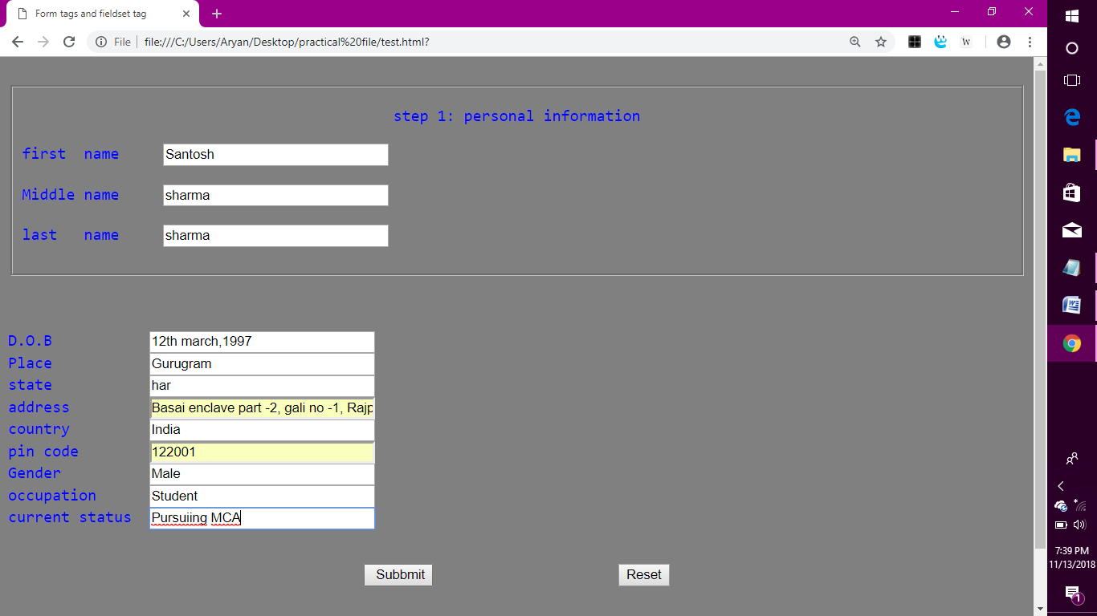

1. ***What is CSS ? Explain ways to insert CSS in html program ?***

*CSS (Cascading Style Sheet):-*

*It defines how to display html elements.*

* *CSS syntax :-*

*A CSS rule set consists of a selector and a declaration block.*

h1 { color:blue; font-size:12px }

h1 :- It points to the html element you want to style.

{ color:blue; font-size:12px } :- It contains one or more declaration seperated by semi colons. Each declaration includes a property name and a value seperated by a colon.

There are three ways to insert CSS in html program.

* External Style Sheet
* Internal Style Sheet
* Inline Style Sheet

1. External Style Sheet :- An External style sheet is ideal when the style is applied to many pages.

* Each page must include a link to the style sheet with the <link> tag in head section.

Example :-

<head>

<link rel=”style sheet” type=”text/CSS” href=”mystyle.css”>

</head>

rel :- It specifies relationship between current document and linked document.

* External style sheet can be written in ant text editor. It should not contain any html tags.

1. Internal Style Sheet :- It should be used when a single document has unique style.

* We define internal styles in the head section of an html page, inside the <style> tag.

Example :-

<head>

<style>

Body

{

background-color:linen;

}

h1

{

Color:maroon;

Margin-left:40px;

}

</style>

</head>

1. Inline Style Sheet :- To use this, add the style attribute to the relevant tag. It can contain any CSS property.

Example:-

<h1 style=”color : blue; margin-left : 30px”;>

This is a heading

</h1>

NOTE 1 :-

* An Inline style has the highest property,which means it will override a style defined.
* Inside <head> tag.
* In External style sheet.
* In a brwoser(a default value).

NOTE 2 :- If the link to the external style sheet is placed after the Internal style sheet in html <head>, the External style sheet will override the Internal style sheet

1. ***Write a program to use CSS background and text formatting attribute.***

*<!doctype html>*

*<html>*

*<head>*

*<title>Css background and text formatting</title>*

*<link rel="stylesheet" type="text/css" href="mystyle.css">*

*<style>*

*h1{*

*letter-spacing:2px;*

*text-shadow:1px 1px yellow;*

*text-align:justify;*

*text-decoration:underline;*

*text-transform:lowercase;*

*}*

*</style>*

*</head>*

*<body>*

*<h1>What is paragraph</h1>*

*<p>*

*Paragraphs are the building blocks of papers. Many students define paragraphs in terms of length:*

*a paragraph is a group of at least five sentences,*

*a paragraph is half a page long, etc. In reality, though, the unity and coherence of ideas among*

*sentences is what constitutes a paragraph.*

*</p>*

*<br>*

*<img src="C:\Users\Aryan\Desktop\mdusy.png"align="middle"height="200"*

*width="200"border="5" align=center>*

*</body>*

*</html>*

*myStyle sheet:-*

body

{

background-color:lightblue;

margin:0px;

}

p

{

margin:20px;

text indent:50px;

word spacing:30px;

line-height:100%;

}

h1

{

font size:25px;

color:red;

margin-left:20px;

text align:center; }

***OUTPUT:-*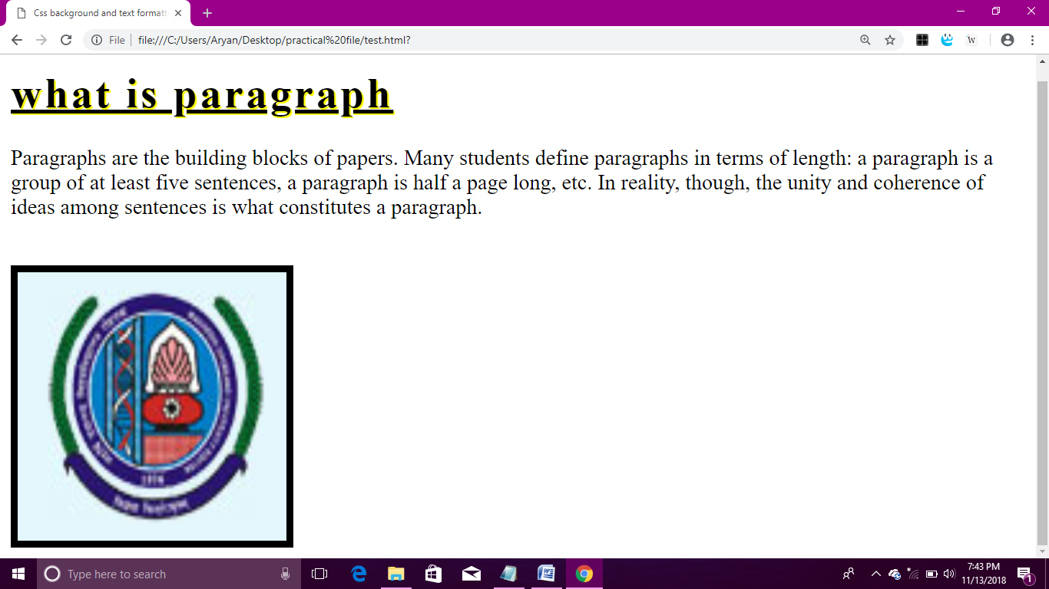**

1. ***Write a program to illustrate the use of table tag***

***With other html tags used inside the table.***

**<html>**

**<head>**

**<title>Table tag </title>**

**<pre>**

**I have completed my graduation with BCA stream**

**from Govt. P.G. College at sec- 9 (Gurugram).**

**This College is affiliated with Maharishi Dyanand University**

**at Rohtak (Haryana)**

**It is A grade university by NAAC .**

**I have done BCA in year June, 2015 to June 2018.**

**I got overall 68.2 % in BCA.**

**Detail of BCA Result**

**</pre>**

**<table align="center" width="50%" border="1" bordercolor="red" style=color:; text-align:center;>**

**<tr>**

**<th>Semester</th><th>Obtain Marks</th><th>Total Marks</th>**

**<th>Percentage</th><tr>**

**<td>First </td><td>303</td>**

**<td>500</td><td>60.6 %</td>**

**</tr><td>Second </td><td>330</td>**

**<td>500</td><td>66 %</td>**

**</tr>**

**<tr><td>Third </td><td>350</td>**

**<td>500</td><td>70 %</td></tr>**

**<tr>**

**<td>Fourth </td>**

**<td>323</td>**

**<td>500</td>**

**<td>64.6 %</td>**

**</tr>**

**<tr>**

**<td>Fifth </td>**

**<td>356</td>**

**<td>500</td>**

**<td>71.2 %</td>**

**</tr>**

**<tr>**

**<td>Sixth </td>**

**<td>384</td>**

**<td>500</td>**

**<td>76.4 %</td>**

**</tr>**

**<tr font>**

**<td><font color=orange size=4>Final Result </font></td>**

**<td>2046</td>**

**<td>3000</td>**

**<td>68.2 %</td>**

**</tr>**

**</table>**

**</body>**

**</html>**

***OUTPUT:***

